Initial Evaluation Form
Key for Coaches

Before you calculate each challenger’s macros, you need to determine if s/he has any health conditions or special considerations that may impact their nutrition plan.

The majority of challengers will NOT have any health conditions or special considerations, but for those who do, we’ve created the resources you need to help your challengers succeed while keeping them safe!

Use this document to determine what calculator and/or protocol to use based on the information challengers provide on their initial evaluation.

KEY TO UNDERSTANDING INITIAL EVALUATION RESPONSES

BLACK | Use Standard Calculator, NO protocols
PURPLE | Use Standard Calculator AND corresponding protocol
RED | Use one of the Special Considerations Calculators AND corresponding protocol
STRIKETHROUGH | Do NOT PROVIDE MACROS. It is not recommended that people with these conditions follow the nutrition part of the challenge. With their doctor’s approval, they can work out.

I do not have any of the health conditions listed below. Use standard calculator, no protocols!

Acid Reflux/GERD
Bariatric surgery (if within the last 12 months, refer to physician—no macros)
Breastfeeding
Crohn's disease
Diverticulosis
Gall bladder removed
Hashimoto's
Hyperlipidemia (high cholesterol)
Heart condition
Hypertension (high blood pressure)
Hyperthyroid
Are you taking medication for this condition?
Yes – Standard Calculator
No – All Other Conditions Calculator and protocol
Hysterectomy: Full Partial
Are you taking hormone replacements?
Yes – Standard Calculator
No – All Other Conditions Calculator and protocol
Hypoglycemia (low blood sugar) – Diabetes Calculator and protocol
Hypothyroid
Are you taking medication for this condition?
Yes – Standard Calculator
No – All Other Conditions Calculator and protocol
Inflammatory bowel disease (IBD)
Polycystic ovary syndrome (PCOS) – All Other Conditions Calculator and protocol
Peptic ulcer disease (PUD)
Trying to become pregnant
Type I diabetes
Type II diabetes: Are you on insulin?
Yes – Diabetes Calculator and protocol
No – Diabetes Calculator and protocol
Ulcerative colitis
Vegan/Vegetarian – Vegan/Vegetarian Calculator and protocol

If a challenger indicates they have any of the following conditions on their initial evaluation, we do NOT recommend they follow the nutrition program. With their doctor’s approval, they can work out.

Diverticulitis
Kidney disease
Liver disease
Organ donation or transplant: Please describe
Pregnant

On average, how many sessions at Fit Body do you plan to attend each week during the challenge?

Do you (or will you) consistently exercise outside of Fit Body (e.g., running, weight lifting, boxing)? Yes No

If yes, please describe the exercise (e.g., running, weight lifting, boxing)?

How many total hours each week do you exercise outside of Fit Body?

If the total number of boot camp sessions + outside exercise is greater than 3 hours per week, refer to the Additional Workouts protocol.

Note to coaches: The body types listed below are only utilized when using the following macro calculators.

- Breastfeeding
- Diabetes
- Other Conditions
- Vegan/Vegetarian

Select your body type
Ectomorph (tall and thin)
Endomorph (bigger frame; carries more fat on their body)
Mesomorph (athletic and muscular)

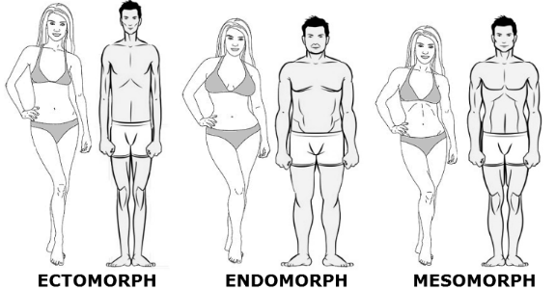

Ideally, you fall into one category. If you didn’t work out, which picture do you most closely resemble?

Ectomorph – Thin individuals characterized by smaller bone structures and thinner limbs. This profile is linked to a fast-metabolic rate and a high carbohydrate tolerance. Ectomorphs eat a diet moderate in protein, high in carbs and low in fat.

Endomorph – Individuals characterized by a larger bone structure with higher amounts of body fat. These individuals do best with a diet that is high in protein and fat and lower in carbohydrates.

Mesomorph – Individuals characterized by a medium-sized bone structure and athletic bodies, holding a significant amount of lean mass. These individuals do best with a good balance of protein, carbs and fat.

The majority of people fall in the endomorphic category. There are not too many ectomorphs who have weight problems. If you need help figuring out your body type, please submit a picture with your initial evaluation.

